Uniprot activity

•  Search for your protein: human glycyl-tRNA

* + Choose only reviewed, human proteins
  + What does “reviewed” mean?
  + 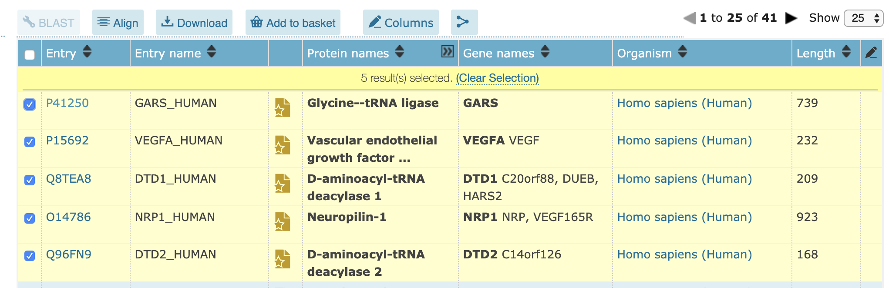Downloadthelistofproteins(UniprotIDs).Thistimepayattention:Makesure you focus on your protein of interest.
  + For the top entry (your protein of interest),
    - What is the UniProt ID?
      * P41250
    - note active site, binding site or other functionally important residues
    - Note natural variants (Feature viewer)
    - Are these natural variants close to the active site in **sequence**?
      * Yes! Some examples…..
      * The original function of our protein is the transfer of glycine to the cognate tRNA. At position 299 is the Glycine binding site. Change from Proline to Leucine at position 298 as well as position 294 (Glycine 🡪 Arginine) apparently leads to a large reduction of the aminoacylation activity (which is the intermediate formed during the “glycine transfer”). This might be due to the fact that the protein structure changes so that the glycine may not be accessible anymore.
      * Same for the second glycine binding site (position 350). The variant (I 🡪 F) at position 334 also reduces aminoacylation activity
      * At position 583 is the ATP binding site. (glycine transfer is ATP dependent). The variant where G 🡪 A at position 652 also leads to a reduction of the aminoacylation activity. But in this case it is not that the transfer of glycine is inhibited/reduced (e.g. due to inaccessibility) but the site where ATP binds.
    - Find out more about your protein. What is its biological function? What does it do?
* Catalyzes the ATP-dependent ligation of glycine to the 3'-end of its cognate tRNA, via the formation of an aminoacyl-adenylate intermediate (Gly-AMP) (PubMed:[17544401](https://www.uniprot.org/citations/17544401), PubMed:[28675565](https://www.uniprot.org/citations/28675565), PubMed:[24898252](https://www.uniprot.org/citations/24898252)).
  + - GO terms give you information about molecular function, cellular component, biological process. You can read more about them here: http://geneontology.org/
    - •Report the GO terms for your protein.

#### GO - Molecular function**i**

* [ATP binding](https://www.ebi.ac.uk/QuickGO/term/GO:0005524) : GO:0005524
* [bis(5'-nucleosyl)-tetraphosphatase (asymmetrical) activity](https://www.ebi.ac.uk/QuickGO/term/GO:0004081): GO:0004081
* [glycine-tRNA ligase activity](https://www.ebi.ac.uk/QuickGO/term/GO:0004820): GO:0004820
* [identical protein binding](https://www.ebi.ac.uk/QuickGO/term/GO:0042802) GO:0042802
* [protein dimerization activity](https://www.ebi.ac.uk/QuickGO/term/GO:0046983) GO:0046983
* [transferase activity](https://www.ebi.ac.uk/QuickGO/term/GO:0016740) : GO:0016740

#### GO - Biological process**i**

* [diadenosine tetraphosphate biosynthetic process](https://www.ebi.ac.uk/QuickGO/term/GO:0015966) GO: 0046983
* [glycyl-tRNA aminoacylation](https://www.ebi.ac.uk/QuickGO/term/GO:0006426) GO: 0006426
* [mitochondrial glycyl-tRNA aminoacylation](https://www.ebi.ac.uk/QuickGO/term/GO:0070150) GO: 0070150
* [tRNA aminoacylation for protein translation](https://www.ebi.ac.uk/QuickGO/term/GO:0006418) GO: 0006418